Toolkit PRIDE 2025 – Northern Ireland
Please note this toolkit is also available on Events and campaigns page of the Sexual Health NI site.
PRIDE 2025 provides an opportunity to celebrate and raise awareness about sexual health.
This year’s theme Take PRIDE in your sexual health invites individuals and organisations to take part and promote inclusive, empowering, and informed conversations around sexual health.
Hover over the heading and click on the arrow iconnext to each heading to expand/collapse the content.

About the event and the toolkit
Dates: Summer 2025
Theme: Take PRIDE in your sexual health
Hashtags: #SexualHealthNI, #TakePrideNI
Published by: Public Health Agency, Communications
Follow us to stay up to date with this initiative:
- Facebook @PublicHealthAgency
- Instagram – @PublicHealthNI
- LinkedIn – public-health-agency-pha
- X – @publichealthni
- Public Health Agency (Vimeo): https://vimeo.com/PublicHealthAgency
- Public Health Agency (YouTube): https://www.youtube.com/user/PublicHealthAgency
- Public Health Agency website
About the toolkit: This toolkit is designed to help you get involved and promote PRIDE 2025 effectively. With a focus on sexual health awareness, this year's theme encourages everyone to celebrate PRIDE by taking ownership of their sexual health and supporting inclusiveness in their communities.
Who is this toolkit for? This toolkit is for individuals, community groups, advocates, and organisations who want to actively engage with and promote the PRIDE 2025 campaign.

Objective
To celebrate PRIDE while promoting confidence and knowledge around sexual health by:
- Signposting to existing supports and services
- Reducing stigma
- Empowering individuals to seek and share information
This aligns with Objective Five of the Sexual Health Action Plan 2023-26, which aims to create an environment where people feel confident in seeking and sharing information about their sexual health.

How to participate
Promotional strategies to help you engage your audience and boost participation during PRIDE:

Collaborate with partners
- Work with local LGBTQ+ groups, schools, influencers, clinics, and PRIDE organisers.
- Share PRIDE event schedule and encourage others to attend or participate in online discussions or workshops.
- Cross-promote events and messaging on social media to extend the campaign’s reach.

Host or attend PRIDE events
- In-person events: Host community workshops, panel discussions, information stalls/tables or outreach activities to facilitate open conversations. [collaborate with healthcare professionals to address common sexual health concerns].
- Virtual events: Organise webinars, live Q&As, virtual peer talks focused on sexual health.
Examples include HIV awareness sessions or sexual health myth-busting panels.

Share stories, testimonials
- Share personal stories or experiences from people who have benefited from open conversations about sexual health [young people, healthcare professionals, or advocates].
- Feature voices from the community: young people, healthcare providers, or advocates.
- Share quotes, clips, or video stories on your social media platforms.

Create engaging content
- Encourage local creators or youth groups to submit video messages, poems, or reels on:
  - ‘What does Taking PRIDE in your sexual health means to you?’
  - Highlight ‘What are the topics you wish we could talk about more?’
  - Highlight support services in fun, positive ways that resonate with LGBTQIA+ audiences.

Key messages to share
- Talk openly, live openly: Open conversations help reduce stigma and empower people to make informed choices about their sexual health.
- Sexual health is health: Sexual health is a vital aspect of overall well-being, and discussions should be open, supportive, and non-judgmental.
- Empowering individuals, especially youth: Encourage individuals to talk to young people and help them make informed, empowered decisions about their sexual health.

Marketing materials
This section includes assets and resources you can use to promote PRIDE 2025 online and offline. All graphics can be found on PRIDE page of the Sexual Health NI website.

Social media posts and hashtags to use
Ready-to-use content (posts, images) for Facebook, Instagram, X, LinkedIn, websites. Use the sample schedule below or tailor content to your audience.
The first post will be published across our platforms on 14 June 2025 at 9am.
- #TakePrideNI
- #SexualHealthNI

Date | Graphics | Caption and hashtags
Thursday 12 June @4pm | 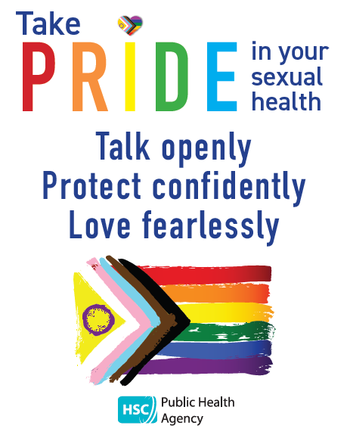 | The PHA are encouraging everyone to Take PRIDE in their sexual health during this year’s PRIDE Festivals and beyond.  You can find out more at www.sexualhealthni.info  #SexualHealthNI #TakePrideNI
Thursday 19 June @4pm | 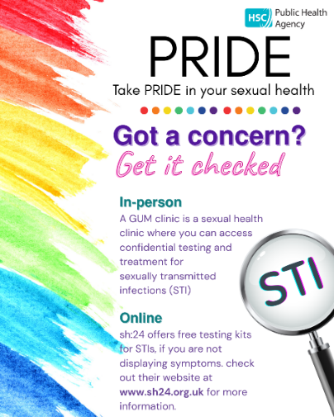 | Testing for STIs is free and can be done from home through online testing or by visiting your local clinic. It is important not to delay in seeking advice and taking this test if you feel you have been at risk. The earlier the condition is diagnosed the more successful treatment is likely to be. You can get a free home testing kit for STIs and HIV at www.sh24.org.uk  www.sexualhealthni.info  #SexualHealthNI #TakePrideNI
Thursday 26 June @4pm | 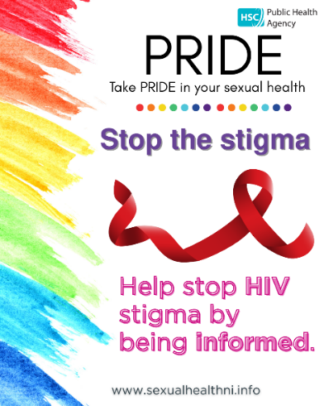 | In Northern Ireland we are working towards eliminating HIV transmission.  Frequent HIV testing, the offer of #PrEP among those eligible, together with prompt treatment among those diagnosed, remain key to ending HIV transmission by 2030.  HIV prevention hinges on early diagnosis and treatment. Testing is key to this.  Testing is available at www.sh24.org.uk  You can find out more at www.sexualhealthni.info  #SexualHealthNI #TakePrideNI
Thursday 3 July @4pm |  | The PHA are encouraging everyone to Take PRIDE in their sexual health during this year’s PRIDE Festivals and beyond.  You can find out more at www.sexualhealthni.info  #SexualHealthNI #TakePrideNI
Thursday 10 July @4pm | 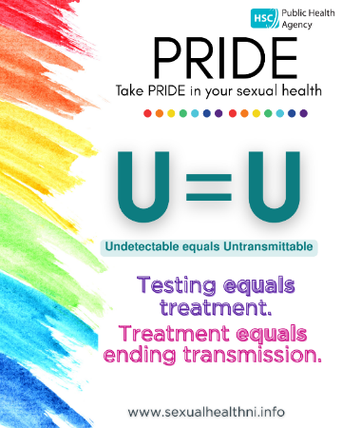 | Treatment for HIV also helps stop transmission – if you are on effective treatment, you can’t pass it on  Testing is available at www.sh24.org.uk  www.sexualhealthni.info  #SexualHealthNI #TakePrideNI
Thursday 17 July @4pm | 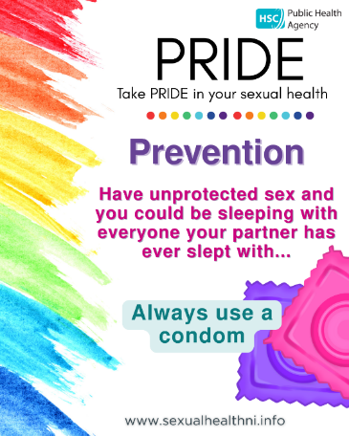 | If you are #sexuallyactive it is important to help protect yourself:  • always use a condom;  • limit your number of sexual partners;  • avail of vaccines and support services;  • get tested quickly if you think you; might be at risk of a STI.  For more info see www.sexualhealthni.info  #SexualHealthNI #TakePrideNI
Thursday 24 July |  | Press release issued
Thursday 24 July @4pm |  | The PHA are encouraging everyone to Take PRIDE in their sexual health during this year’s PRIDE Festivals and beyond.  You can find out more at www.sexualhealthni.info  #SexualHealthNI #TakePrideNI
Thursday 31 July @4pm | 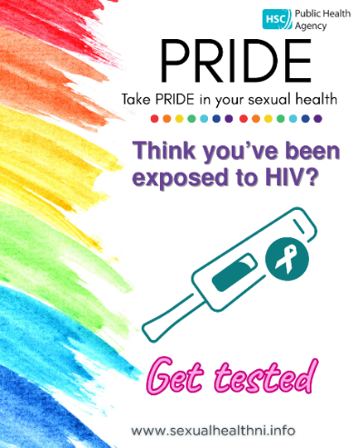 | Reasons to have an HIV test  • Have a new sexual partner  • Have had unprotected sex  • Have paid for sex  • Have shared injecting drug equipment  Testing for HIV is free and involves a simple blood test. It can be done from home through an online testing kit or by visiting your local clinic.  You can get a free home testing kit for HIV at www.sh24.org.uk  www.sexualhealthni.info  #SexualHealthNI #TakePrideNI
Thursday 7 August @4pm | 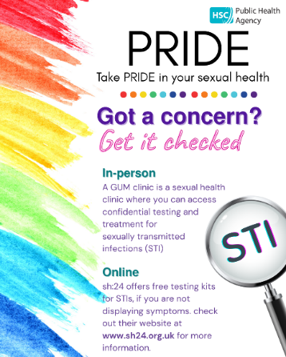 | Testing for STIs is free and can be done from home through online testing or by visiting your local clinic. It is important not to delay in seeking advice and taking this test if you feel you have been at risk. The earlier the condition is diagnosed the more successful treatment is likely to be. You can get a free home testing kit for STIs and HIV at www.sh24.org.uk  www.sexualhealthni.info  #SexualHealthNI #TakePrideNI
Thursday 14 August @4pm | 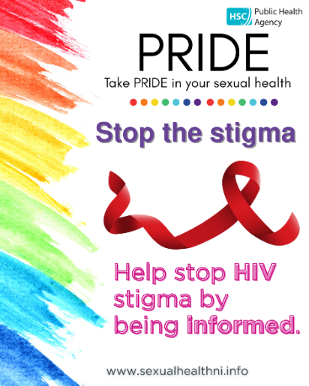 | In Northern Ireland we are working towards eliminating HIV transmission.  Frequent HIV testing, the offer of #PrEP among those eligible, together with prompt treatment among those diagnosed, remain key to ending HIV transmission by 2030.  HIV prevention hinges on early diagnosis and treatment. Testing is key to this.  Testing is available at www.sh24.org.uk  You can find out more at www.sexualhealthni.info  #SexualHealthNI #TakePrideNI
Thursday 21 August @4pm | 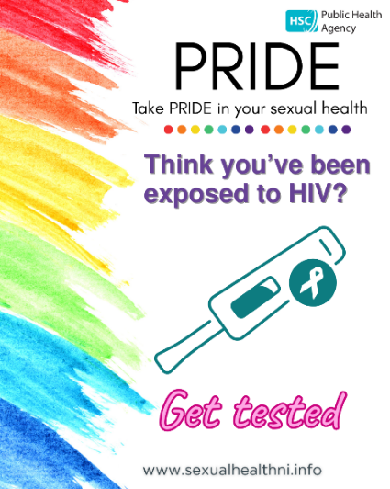 | Reasons to have an HIV test  • Have a new sexual partner  • Have had unprotected sex  • Have paid for sex  • Have shared injecting drug equipment  Testing for HIV is free and involves a simple blood test. It can be done from home through an online testing kit or by visiting your local clinic.  You can get a free home testing kit for HIV at www.sh24.org.uk  www.sexualhealthni.info  #SexualHealthNI #TakePrideNI
Thursday 28 August @4pm | 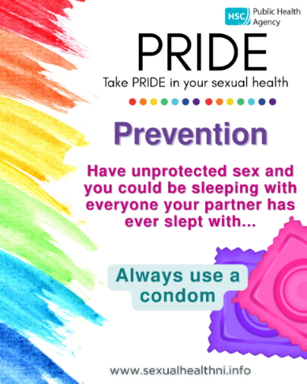 | If you are #sexuallyactive it is important to help protect yourself:  • always use a condom;  • limit your number of sexual partners;  • avail of vaccines and support services;  • get tested quickly if you think you; might be at risk of a STI.  For more info see www.sexualhealthni.info  #SexualHealthNI #TakePrideNI

Posters, flyers, web banner, email signature
Download PRIDE 2025 materials - These print and digital materials were designed to promote PRIDE in public areas, PRIDE stalls/tables, clinics, schools, and workplaces.
Poster theme: “Take PRIDE in your sexual health”
Poster name | How to use
PRIDE 25 Advertisement insert A5 | Small format flyer perfect for handing out at events, inserting in information packs or displaying in waiting rooms.
PRIDE 25 Belly poster A3  PRIDE 25 Belly poster A4 | Designed to be wrapped around poles, barriers, or railings.
PRIDE 25 Poster A3  PRIDE 25 Poster A4 | Standard poster for walls, noticeboards, clinic entrances, school bulletin boards, staff rooms.
PRIDE 25 Social media graphic | Optimised for sharing on social media platforms (Instagram, Facebook, X)
PRIDE 25 Web banner and email signature | Add to websites, newsletters, email footers to spread the message.

Press release
The official press release will be issued on Thursday 24 July at 9am. You can access a copy of it on the News page of the Public Health Agency website.

Additional resources and PRIDE around NI
- Useful resources and links - Sexual Health NI
- Press release will be published on PHA’s corporate site news page on 24 July at 9am.
- Downloadable resources: Get access to posters, flyers, web banners, email signature social media posts and more on the website PRIDE - Sexual Health NI
- Find out about parades, workshops happening during PRIDE around Northern Ireland. For the most accurate and up-to-date information, please refer to the official websites or social media pages of each event.
  - Date: 14th June 2025
Omagh Pride 2025: Celebrate Diversity, Equality, and Love in Omagh
Location: Omagh
Description: Omagh Pride is set to celebrate the LGBTQ+ community with various events and activities.
  - Date: Saturday, 28th June 2025
Mid and East Antrim Pride
Location: Ballymena
Description: This inaugural Pride event in Ballymena aims to celebrate diversity and promote inclusivity within the community.
  - Dates: Friday, 18th July to Sunday, 27th July 2025
Pride Day and Parade: Saturday, 26th July 2025
Belfast Pride Festival
Description: Featuring over 150 events across ten days, the centrepiece is the Pride Parade, which commences at 1:00 PM on 26th July. belfastpride.com
  - Date: 2nd August 2025
Causeway Pride
Location: Causeway Coast area
Description: Causeway Pride aims to bring together the community in celebration of LGBTQ+ identities.
  - Dates: 23rd to 24th August 2025
Foyle Pride Festival
Location: Derry/Londonderry
Description: Celebrating its 32nd anniversary, Foyle Pride represents the LGBTQ+ community in the North West and includes a parade and festival on Saturday, 23rd August.
- For your calendar:
  - Omagh Pride – Sat 14th June
  - Mid & East Antrim Pride – Sat 28th June
  - Belfast Pride – 18-27th July
  - Causeway Pride – Say 2nd Aug
  - Mid Ulster Pride – Sat 9th Aug
  - Trans Pride – Sat 13th Aug
  - Foyle Pride – Sat 23rd Aug
  - Newry Pride – Sat 30th Aug
  - Fermanagh Pride – September tbc
  - Lurgan/Bangor/Armagh TBC

