Theme and event toolkit for Sexual Health Week 2025
Theme: Open Conversations
Dates: 10-16 February 2025
Published by: Public Health Agency, Communications
About the toolkit: This toolkit is designed to help you get involved and promote Sexual Health Week effectively.
Who is this toolkit for? An individual, a community group, or an organisation, this toolkit will provide the resources you need to participate in and promote this event.

Objective
To create a culture of openness and empowerment around sexual health by encouraging open conversations. This aligns with Objective Five of the Sexual Health Action Plan 2023-26, which aims to create an environment where people feel confident in seeking and sharing information about their sexual health.

Marketing materials
This section contains customisable assets for you to use during Sexual Health Week.

1. Social media posts, images, videos, hashtags
We’ve created ready-to-use social media templates for you to post on Facebook, Instagram, X, and LinkedIn. These can be downloaded and shared with your community.
Follow us to keep up-to-date with PHA’s participation during the Sexual Health Week:
Facebook @PublicHealthAgency
Instagram – @PublicHealthNI
LinkedIn – public-health-agency-pha
X – @publichealthni
Public Health Agency corporate site
Public Health Agency (Vimeo): https://vimeo.com/PublicHealthAgency
Public Health Agency (YouTube): https://www.youtube.com/user/PublicHealthAgency

Date | Graphic | Caption and hashtags
Sun 9 Feb | 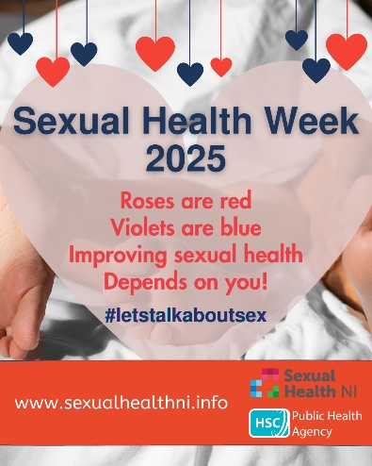 | This Sexual Health Week (10-16 February) we’re encouraging people to talk about sex, including sexual wellbeing and healthy relationships, and benefit from the confidence that comes from being informed.  www.sexualhealthni.info  #sexualhealthweek  #letstalkaboutsex
Mon 10 Feb | Video of Frances  https://vimeo.com/1053448492 | This Sexual Health Week (10-16 February) let’s talk about sex. Get to know more about sexual wellbeing, healthy relationships and the confidence that comes from being informed.  www.sexualhealthni.info  #sexualhealthweek  #letstalkaboutsex
Tue 11 Feb | 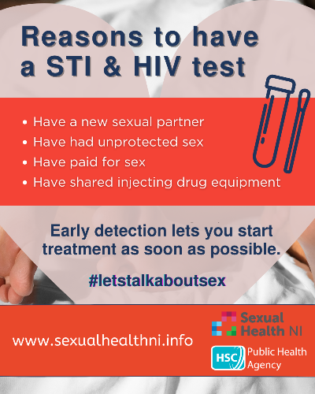 | Let's talk...TESTING  Have an HIV test if you:  • have a new sexual partner;  • have had unprotected sex;  • have paid for sex;  • have shared injecting drug equipment.  Testing for HIV is free and involves a simple blood test. It can be done from home through an online testing kit or by visiting your local clinic.  You can get a free home testing kit for HIV at www.sh24.org.uk  www.sexualhealthni.info  #sexualhealthweek  #letstalkaboutsex
Wed 12 Feb | 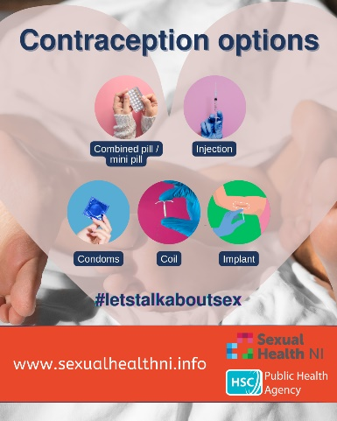 | Let's talk...CONTRACEPTION  - There are a range of contraceptives available to help prevent unplanned pregnancy and what works best will depend on what matters to you.  - Condoms are the only form of contraception that can help protect against both pregnancy and STIs.  - Get tested quickly if you think you might be at risk of an STI.  For more info see www.sexualhealthni.info  #sexualhealthweek  #letstalkaboutsex
Thur 13 Feb | Video of Rachel  https://vimeo.com/799150146 | This Sexual Health Week (10-16 February) let’s talk about sex. Get to know more about sexual wellbeing, healthy relationships and the confidence that comes from being informed.  www.sexualhealthni.info  #sexualhealthweek  #letstalkaboutsex
Fri 14 Feb | 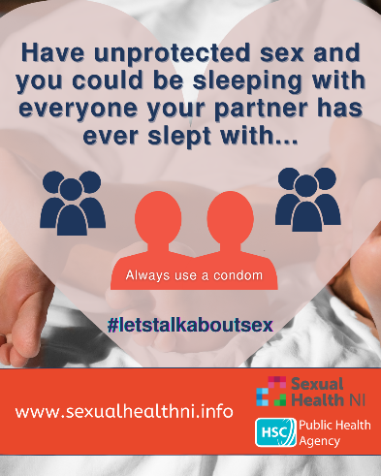 | Let's talk...PROTECTION  If you are #sexuallyactive it is important to help protect yourself:  - always use a condom;  - limit your number of sexual partners;  - avail of vaccines and support services;  - get tested quickly if you think you; might be at risk of a STI.  For more info see www.sexualhealthni.info  #SexualHealthWeek  #letstalkaboutsex
Sat 15 Feb | 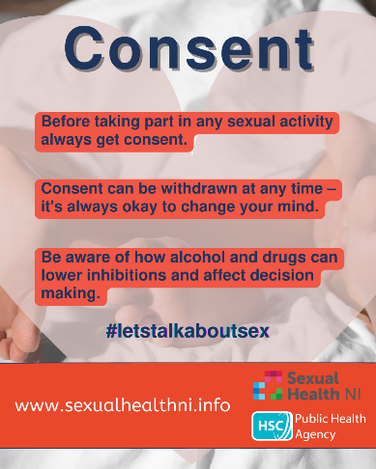 | Let's talk...CONSENT  Always trust your instinct and be empowered to say ‘No’ to anything or any situation you are uncomfortable with.  For more info see www.sexualhealthni.info  #sexualhealthweek  #letstalkaboutsex

2. Hashtags to use
- #SexualHealthWeek
- #LetsTalkAboutSex

How to participate
Promotional strategies to help you engage your audience and boost participation in Sexual Health Week:

1. Collaborate with partners
- Partner with local organisations, schools, clinics, and influencers to promote the message of open conversations. Use cross-promotion on social media to extend the event’s reach.
- Share the Sexual Health Week event schedule and encourage others to attend or participate in online discussions or workshops.

2. Host events
- In-person events: Host workshops, discussions, or outreach activities to facilitate open conversations. [collaborate with healthcare professionals to address common sexual health concerns].
- Virtual events: Organise webinars or live chats focused on sexual health topics [awareness sessions internally in your organisation similar to HIV awareness sessions].

3. Share testimonials and success stories
- Share personal stories or experiences from people who have benefited from open conversations about sexual health [young people, healthcare professionals, or advocates].
- Feature quotes or video clips from participants who have shared their experiences on social media.

4. Create content
- Video content: Create and share short videos explaining why open conversations about sexual health matter.

Key messages to share
- Talk openly, live openly: Open conversations help reduce stigma and empower people to make informed choices about their sexual health.
- Sexual health is health: Sexual health is a vital aspect of overall well-being, and discussions should be open, supportive, and non-judgmental.
- Empowering individuals, especially youth: Encourage individuals to talk to young people and help them make informed, empowered decisions about their sexual health.

Additional resources & support information
- Events and videos: Find out about events happening during the week, watch inspiring videos of young people, healthcare professionals
- Downloadable resources: Social media assets available within this toolkit.
- Press release: Check the PHA’s corporate site news page on 10 February for the press release.

