World AIDS Day Social Media Schedule for Novemeber
Date | Lead | Graphic | Text
Thur 7 Nov 7pm | PHA | 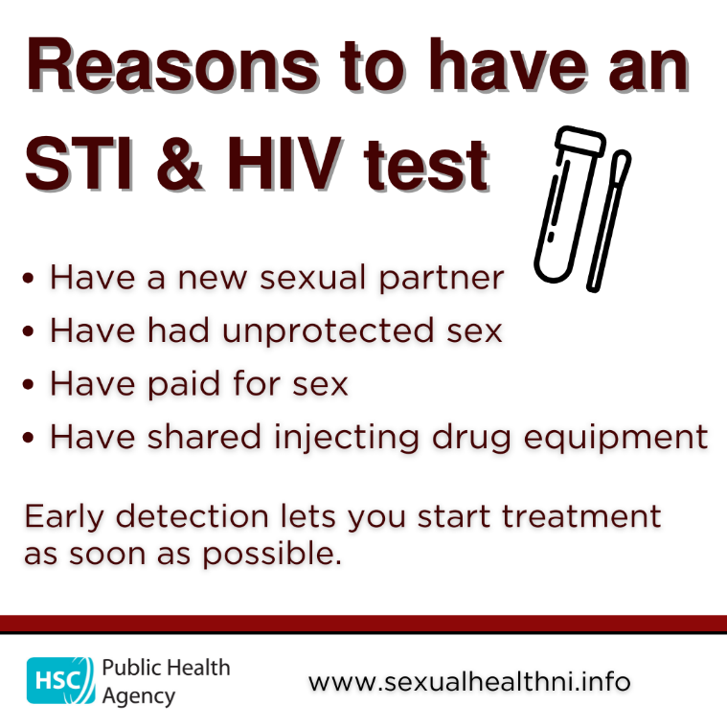 | Testing for STIs and HIV is free and can be done from home through online testing or by visiting your local clinic.  It is important not to delay in seeking advice and taking this test if you feel you have been at risk. The earlier the condition is diagnosed the more successful treatment is likely to be.  You can get a free home testing kit for STIs and HIV at www.sh24.org.uk  www.sexualhealthni.info
Thur 14 Nov @7pm | PHA | 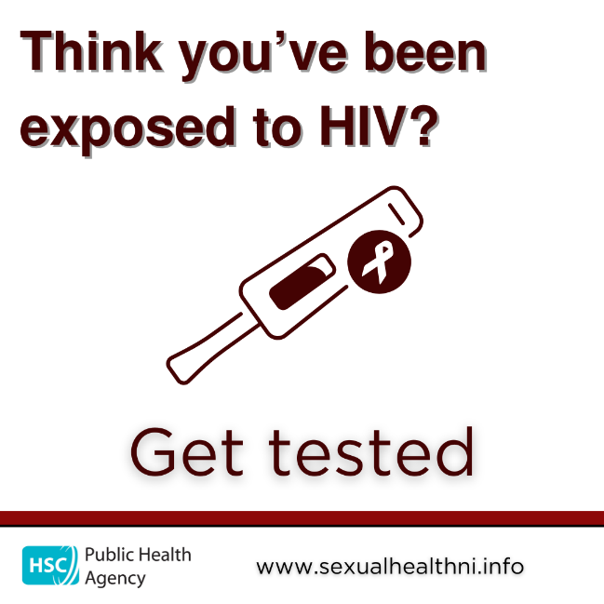 | Reasons to have an HIV test  - Have a new sexual partner  - Have had unprotected sex  - Have shared injecting drug equipment  Testing for HIV is free and involves a simple blood test. It can be done from home through an online testing kit or by visiting your local clinic.  You can get a free home testing kit for HIV at www.sh24.org.uk  www.sexualhealthni.info
Thur 21 Nov @7pm | PHA | 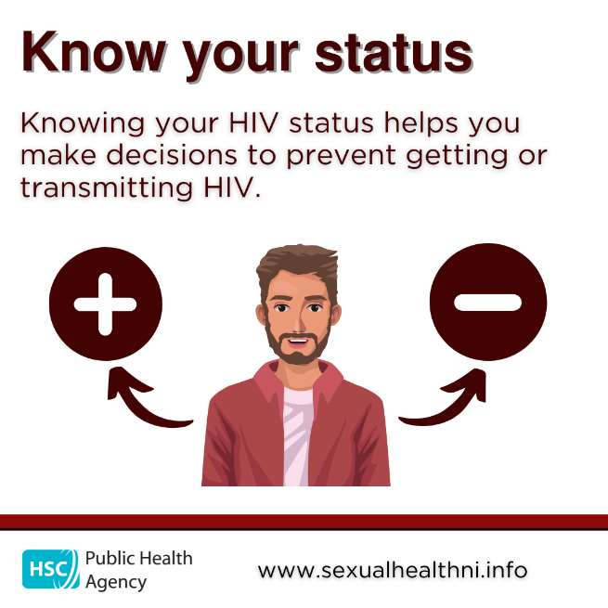 | Think you’ve been exposed to HIV?  Testing for HIV is free and involves a simple blood test and can be done from home through an online testing kit or by visiting your local clinic.  It is important not to delay in seeking advice and taking this test if you feel you have been at risk. The earlier the condition is diagnosed the more successful treatment is likely to be.  You can get a free home testing kit for HIV at www.sh24.org.uk  www.sexualhealthni.info
Thursday 28th November @9am | PHA | World AIDS Day  Press release issued
Thursday 28th November @4pm | PHA | 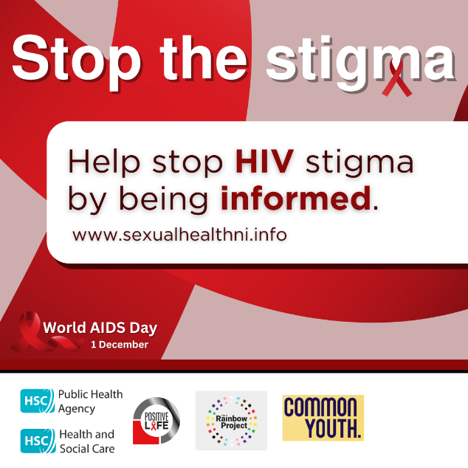 | Ahead of World AIDS Day on 1 December 2024, we are encouraging everyone to help stop HIV stigma by being informed.  If detected early, modern HIV treatment not only keeps you alive, it helps stop the virus being passed on.  Testing, treatment and prevention are free for everyone in Northern Ireland.  Testing is available at www.sh24.org.uk  Find out about HIV at www.sexualhealthni.info
Friday 29th November @4pm | PHA | 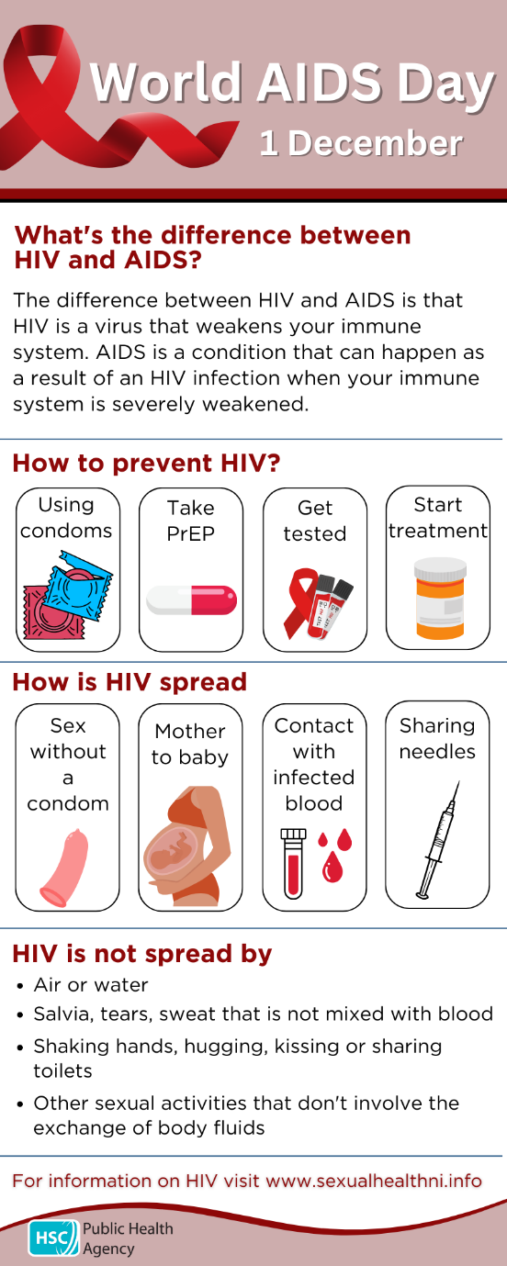 | Testing for HIV is free and involves a simple blood test and can be done from home through an online testing kit or by visiting your local clinic.  It is important not to delay in seeking advice and taking this test if you feel you have been at risk. The earlier the condition is diagnosed the more successful treatment is likely to be.  You can get a free home testing kit for HIV at www.sh24.org.uk  www.sexualhealthni.info
Saturday 30th November @10am | PHA | 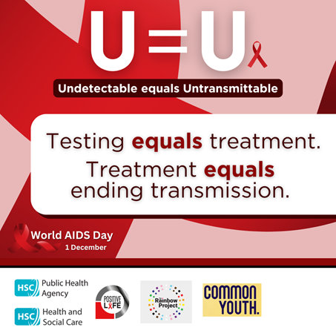 | Ahead of World AIDS Day on 1 December 2024, the PHA is encouraging testing and treatment.  Treatment for HIV also helps stop transmission – if you are on effective treatment, you can’t pass it on  Testing is available at www.sh24.org.uk  www.sexualhealthni.info
Sunday 1 December @10am | PHA | 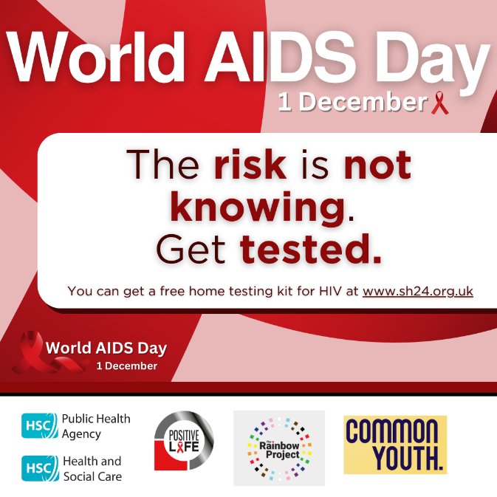 | Today is World AIDS Day.  In Northern Ireland we are working towards eliminating HIV transmission.  Frequent HIV testing, the offer of #PrEP among those eligible, together with prompt treatment among those diagnosed, remain key to ending HIV transmission by 2030.  HIV prevention hinges on early diagnosis and treatment. Testing is key to this.  Testing is available at www.sh24.org.uk  www.sexualhealthni.info

